**CHAPTER**

**SYSTEM DESIGN**

**System Architecture**

**AI Driven Fraud Detector**

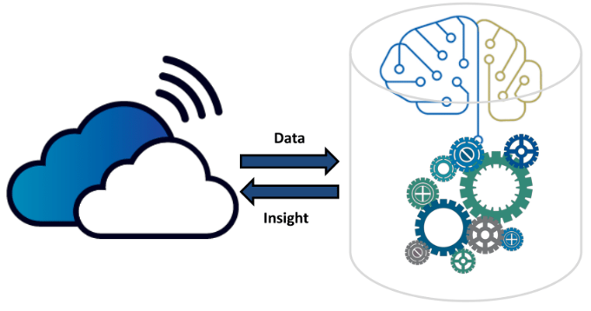

Preprocessing



Register

View Flagged Request

User management

Login

Text Recognition

Text Region Detection

Extract Upload Files Documents

**Donor**

**Admin**

**Fund Requester**

**Medical Fund Fraud Detector Web App**

View Fund Request

View Donor Responses



Login

Post Fund Request

Upload Documents

Approve/Block Req

Receive Donation

Notification



Register

Login

View Genuine Req.

Donate Payment

Notification

Hospital Database

Pattern Matching

Fund Request Verification